Politecnico di Torino

Master Degree in Artificial Intelligence and Data Analytics

Machine Learning and Pattern Recognition
Prof. Sandro Cumani

Fingerprint Spoofing
February 1, 2024
Roberto Gaetano, s318989
Distefano Giuseppe, s309787

1 Introduction

1.1 Problem Overview
The primary objective of the project involves creating a classifier capable of distinguishing between an authentic fingerprint or a spoofed fingerprint. The dataset comprises fingerprint images represented as embeddings, with each embedding described by 10 continuous variables. These embeddings are associated with either authentic fingerprints (labeled as 1) or spoofed fingerprints (labeled as 0), with the latter belonging to 6 distinct sub-classes representing various spoofing methods.

The dataset is split into two files: Train.txt (containing 800 authentic and 1525 spoofed fingerprints) and Test.txt (comprising 2400 authentic and 5304 spoofed fingerprints). Both files contain rows representing individual samples, where the first ten entries denote features, and the final entry indicates the class label (0 for spoofed and 1 for authentic fingerprints). The dataset exhibits class imbalance, with more samples in the spoofed fingerprint class.

The goal is to perform classification using diverse techniques, analyze outcomes, and justify the chosen methodologies. Notably, the dataset's imbalance warrants attention, as the spoofed fingerprint class is significantly larger than the authentic class.

Moreover, the target application requires equal prior probabilities for authentic and spoofed classes. However, misclassifying a spoofed fingerprint as authentic incurs a higher cost due to potential security implications. The application's working point is defined as (πT = 0.5, Cfn = 1, Cfp = 10), where πT represents the application prior, Cfn denotes the cost of false negatives, and Cfp signifies the cost of false positives. The analysis will also explore the model's performance across different working points.

1.2 Feature analysis
Before going in depth into a detailed discussion of classification and validation strategies, it is useful to thoroughly explore and examine our dataset.
The provided figures depict histograms for each of the 10 features. Notably, certain features, like feature 1 and 3, exhibit a distribution reminiscent of a Gaussian Bell curve.
Upon closer inspection of other plots, it becomes evident that some features distinctly differentiate between the two classes. Notably, feature 8 emerges as one of the most discriminant features in the dataset. Additionally, there are observations indicating that certain features could be better represented by multiple Gaussian Bell curves, as seen in features 6, 7, and 9.
The histogram plots offer insights into the distribution of features and their relevance for classification. Features such as 2, 3, 4, and 8 demonstrate minimal overlap in their histograms, suggesting their potential usefulness for classification. These features provide valuable information for determining the class to which a fingerprint belongs. On the contrary, other features display significant histogram overlap, so these will not discriminate well our classes.

This preliminary exploration of our data sets the foundation for a comprehensive understanding of feature distributions and their potential impact on classification and validation strategies. For example, it’s evident from the histograms that the features exhibit shapes resembling Gaussian distributions. Therefore, Gaussian models may prove to be effective for our intended purpose.
Cambia colori

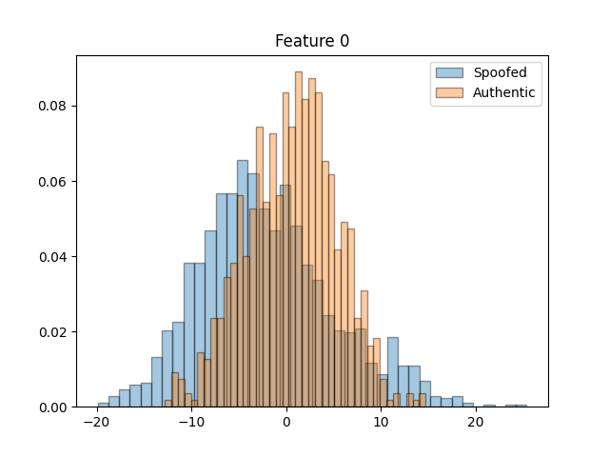 | 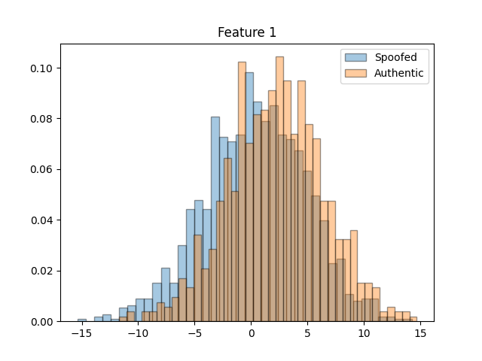 | 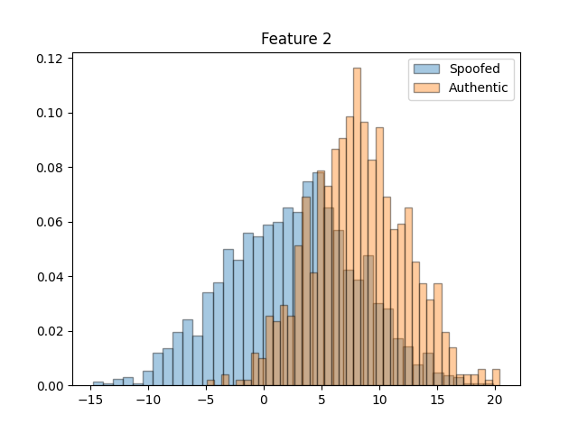
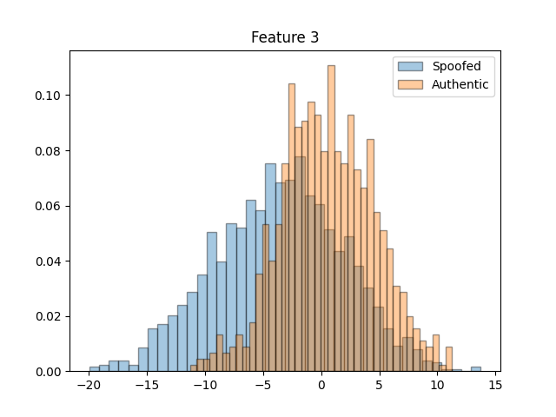 | 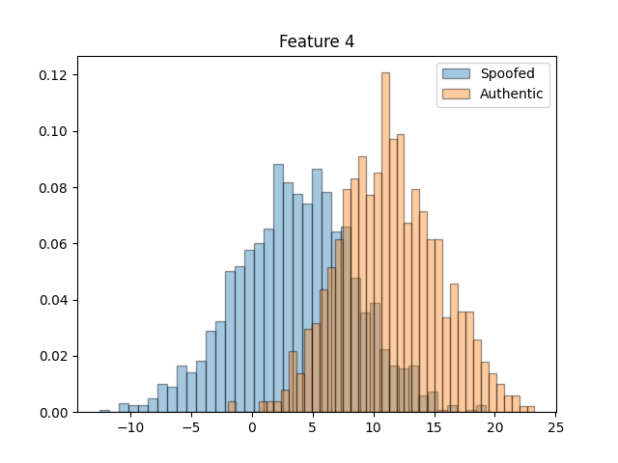 | 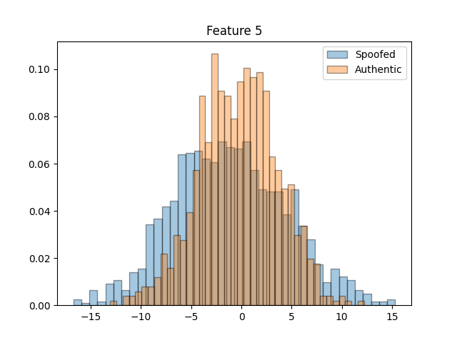
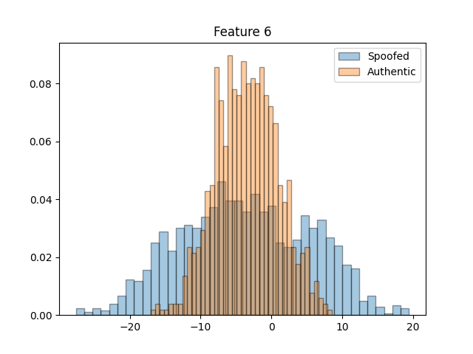 | 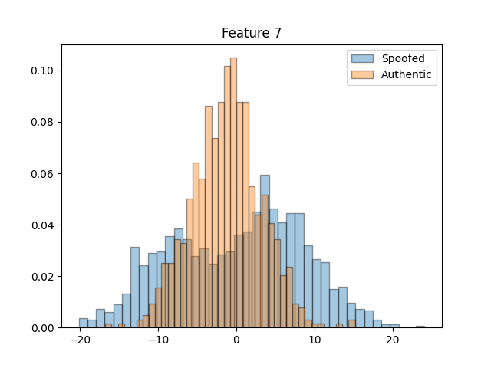 | 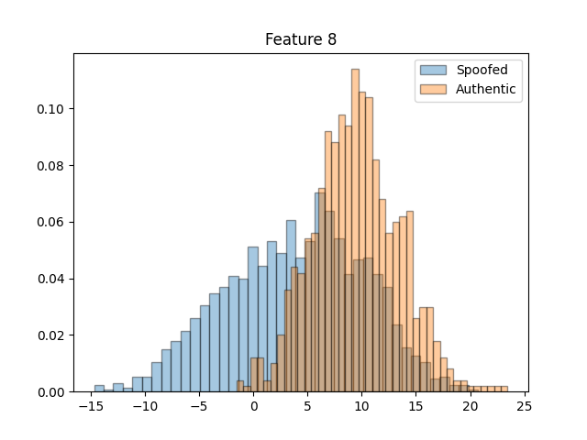
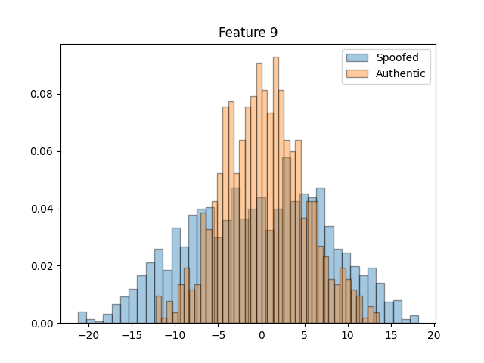
Figure 1: Histograms of features

Examining the correlation analysis, we can draw insights by observing the Pearson Correlation represented as a heatmap. The first heatmap provides an overview of the correlation for each feature across the entire dataset, the others two denote correlation with the target and non-target classes. Despite slight variations across heatmaps, a notable finding is that features are generally not strongly correlated, except for one or two features. This suggests that eliminating some dimension may not result in a substantial loss of information.
With the Pearson correlation coefficient equal to:

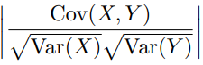
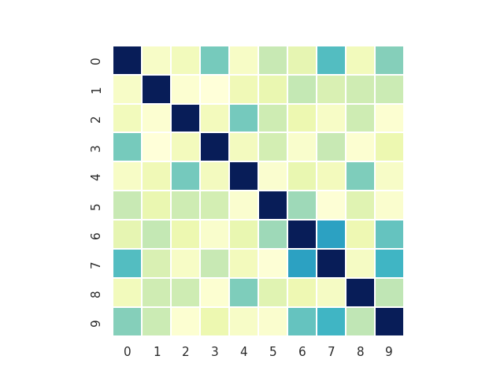  Heatmap: 1 All samples | 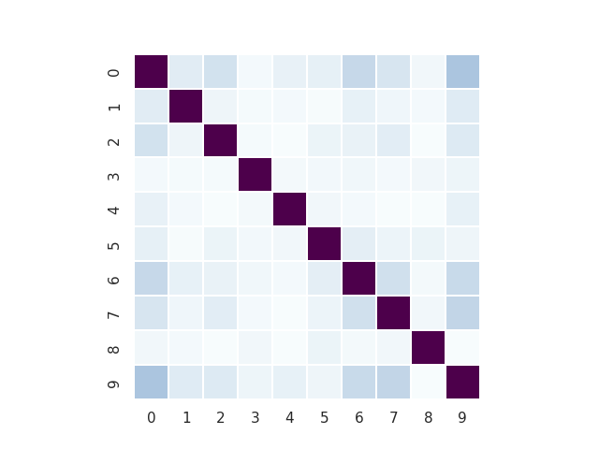  Heatmap: 2 Spoofed fingerprint samples | 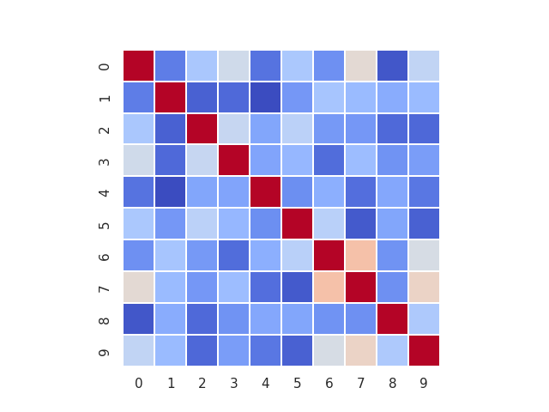  Heatmap: 3 Authentic fingerprint samples
Figure 2: Heatmaps

Exploring the application of Linear Discriminant Analysis (LDA) to enhance class separation, we aim to determine the linear separability of our binary classification problem. LDA enables the estimation of at most C-1 directions, where C represents the number of classes. Examining the resulting plot, it appears that a linear classifier could perform effectively as the classes are reasonably well-separated, with a small overlapping area. Thus, LDA suggests that a linear classifier may adequately discriminate between classes.

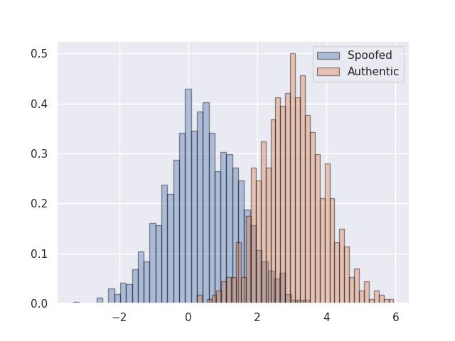
Figure 3: LDA

Utilizing PCA and focusing on the two most relevant dimensions, it becomes evident that the classes may not exhibit linear separability, suggesting that quadratic decision surfaces might be more appropriate for classification. In addition, we can see that the non-target (Spoofed fingerprint) class is composed of several clusters, perhaps representing different spoofing approaches.
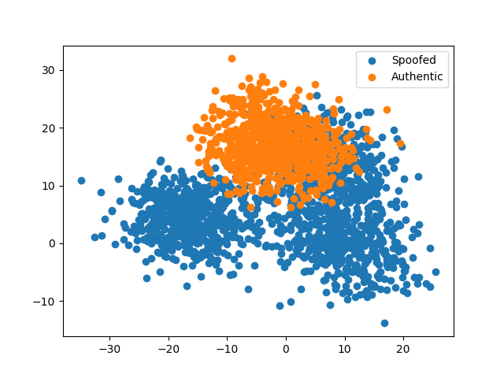
Figure 4: Scatter plot of all features after PCA with m = 2 dimensions.

1.3 Training
The analysis focuses on robust evaluation methodologies, diverse application scenarios, model selection criteria, and the crucial consideration of imbalanced priors. The exploration of preprocessing techniques enhances our understanding of their relevance in the fingerprint recognition task. The comprehensive approach ensures a thorough evaluation of classifiers under various conditions, contributing to informed decision-making for the final model.
Expanding on our analysis, we delve deeper into the methodology and considerations involved in training and evaluating classifiers for the fingerprint recognition task.
Firstly, we adopted a K-Fold approach with K=5, shuffling the data before splitting to create homogeneous folds. This method allows us to efficiently utilize the limited dataset for both training and validation, providing a robust evaluation framework. Then, for performance evaluation, we used the normalized minimum detection cost function (minDCF). This metric represents the cost associated with optimal decision-making, considering the effective prior that accounts for both the prior probability of the authentic fingerprint class and the cost of errors. The effective prior adjusts for the fact that the cost of False Positives (Cfp) is greater than the cost of False Negatives (Cfn).
Application scenarios are basically three:
- Uniform prior application

(πT = 0.5, Cfn = 1, Cfp = 10)

- Unbalanced applications with priors biased towards one class:
(πT = 0.1, Cfn = 1, Cfp = 10)
(πT = 0.9, Cfn = 1, Cfp = 10)
These scenarios help assess the impact of imbalanced priors on classifier performance.
In addition, different preprocessing techniques, such as Z-normalization and PCA, have been employed to assess their impact on classifier performance.

2 Gaussian Classifiers
We’ll start considering Multivariate Gaussian Classifiers (MVG) for those with the following covariance matrices: Full Covariances, Tied Covariances, Diagonal Covariances. Also, we will try to combine different pre-process techniques like Gaussianization, Z-Score and PCA, to determine if them are effective. Since histograms have shown that some features approximately have a gaussian distribution, it is expected that the Generative Models work well for this dataset.

2.1 Objective function
___

2.2 Expectations
___

2.3 Results
In the following tables are reported the normalized minimum detection costs for the different scenarios.
MVG Classifier
PCA | minDCF, π = 0.1 | minDCF, π = 0.5 | minDCF, π = 0.9
- | 0.000 | 0.000 | 0.000
9 | 0.000 | 0.000 | 0.000
8 | 0.000 | 0.000 | 0.000
7 | 0.000 | 0.000 | 0.000
6 | 0.000 | 0.000 | 0.000
5 | 0.000 | 0.000 | 0.000

Naive Bayes Classifier
PCA | minDCF, π = 0.1 | minDCF, π = 0.5 | minDCF, π = 0.9
- | 0.000 | 0.000 | 0.000
9 | 0.000 | 0.000 | 0.000
8 | 0.000 | 0.000 | 0.000
7 | 0.000 | 0.000 | 0.000
6 | 0.000 | 0.000 | 0.000
5 | 0.000 | 0.000 | 0.000

MVG Classifier with tied covariance
PCA | minDCF, π = 0.1 | minDCF, π = 0.5 | minDCF, π = 0.9
- | 0.000 | 0.000 | 0.000
9 | 0.000 | 0.000 | 0.000
8 | 0.000 | 0.000 | 0.000
7 | 0.000 | 0.000 | 0.000
6 | 0.000 | 0.000 | 0.000
5 | 0.000 | 0.000 | 0.000

Naive Bayes Classifier with tied covariance
PCA | minDCF, π = 0.1 | minDCF, π = 0.5 | minDCF, π = 0.9
- | 0.000 | 0.000 | 0.000
9 | 0.000 | 0.000 | 0.000
8 | 0.000 | 0.000 | 0.000
7 | 0.000 | 0.000 | 0.000
6 | 0.000 | 0.000 | 0.000
5 | 0.000 | 0.000 | 0.000
___

3 Logistic regression

3.1 Objective function
___

3.2 Expectations
___

3.3 Results

3.3.1 Linear logistic regression
___

3.3.2 Quadratic logistic regression
___

3.4 Conclusions
___

